**PD / BI Tab Layout**

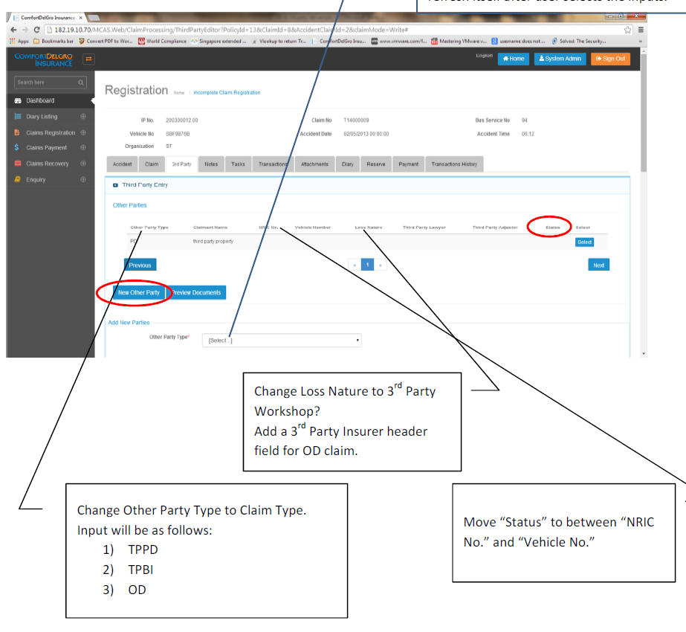

Dropdowns:

1) TPPD Claim

2) TPBI Claim

New Claim Type

Add New Claim Type

**1) On the PD/BI Screen layout – The Top Portion is to display the list of TPPD & TPBI Claims that have been created. The Bottom Portion is for users to click on a Button “New Claim Type”**

**2) Header Labels for the Top Portion to be worked on later – after confirming with CDGI.**

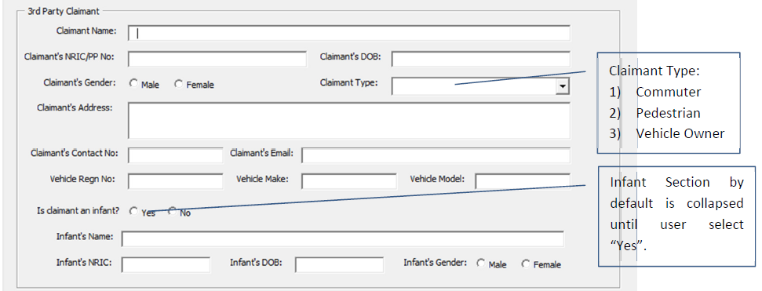

Set To TPPD if TPPD is chosen / TPBI if TPBI is chosen

Unique Subset Number of Parent Claim Number (generated from Accident Tab), e.g. C00001-PD01 / C00001-BI01

Add 4) Company

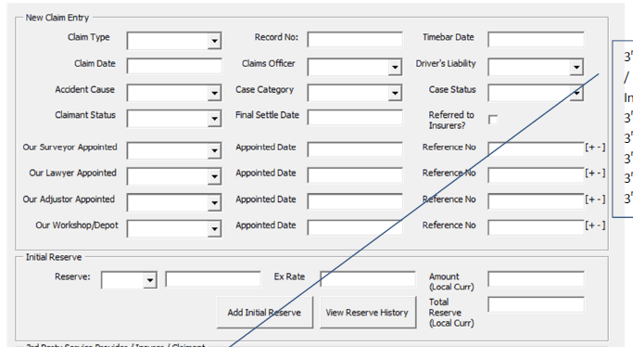

Will check if there is a need to add this >> Recoverable (From Insurer): Yes / No (Default Is No).

If yes, this Claim Record will flow to Claims Recovery Processing after User clicks on Complete Button

Claimant Status:

Input:

* Pending
* Finalized
* Cancelled
* Reopened

Initial Reserve (Popup)

Populate from Total Field Of Popup

**Initial Reserve (Popup)**

**-- For TPPD**

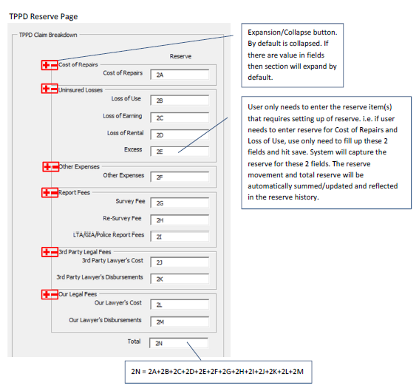

Save Button

**-- For TPBI**

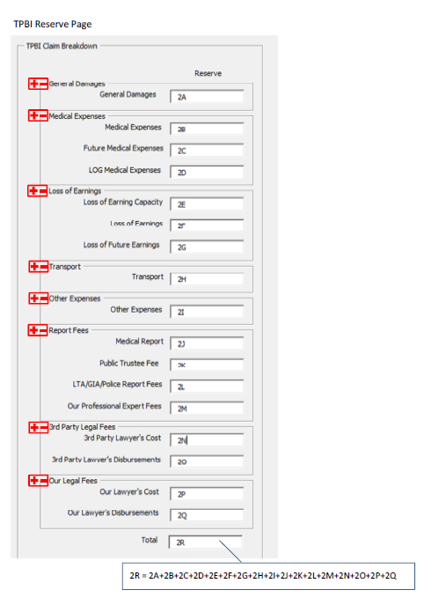

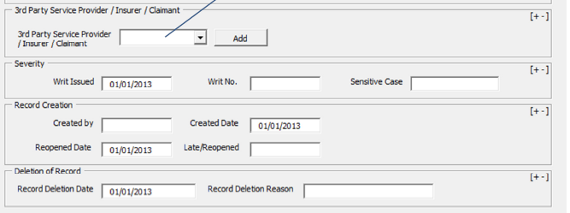

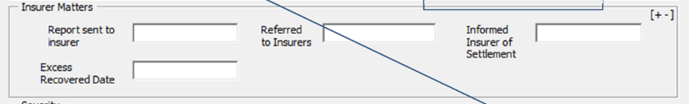

Insurer Matters to add after 3rd Party and before Severity

Field Open when Claimant Status = Reopened

Field Open when Claimant Status = Cancelled

Third Party Service Provider Popup

**Third Party Service Provider (Popup)**

